CYBER 5

Iteration One

Matthew Roth, Hannah Sadikovic, Faysal Bulbul, Chris Humphrey, Logan Coleman

Table of Contents……………………………………………………………………………………………………2

System Request………………………………………………………………………………………………………3

Narrative……………………………………………………………………………………………………4

Problem Statement………………………………………………………………………….…4

Business Case……………………………………………………………………………………8

Feasibility Considerations………………………………………………………………….8

Process Models……………………………………………………………………………………….11

As-Is………………………………………………………………………………………………11

To-Be…………………………………………………………………...………………..……….12

Agile Stories…………………………………………………………………………………………….13

Vision Document……………………………………………………………………………………..14

Team Charter…………………………………………………………………………………………..20

System Request

TO: Kathy Meyer

FROM: Cyber 5

DATE: September 13, 2021

SUBJECT: Cardinal Cupboard Systems Analysis and Design

This report is intended to describe the current problems Cardinal Cupboard is facing and to explain why Cardinal Cupboard needs Cyber 5’s help. Key stakeholders will be identified. A business case will be described, and a technical, organizational, and economic feasibility study will be conducted.

The business need we have identified consists of increasing visibility, increasing donations, and making internal systems more cohesive and integrated. The current system that supports this business need is a web site that lacks many of the business processes that we have identified as key processes in our analyses. By fixing these problems we will fulfil the business need and create a business value for our client, Cardinal Cupboard. The value will be monetary as we will help Cardinal Cupboard bring in increased revenue.

|  |  |  |
| --- | --- | --- |
| Element | Description | Examples |
| Project Sponsor | The person who initiates the project, and who serves as the primary point of contact on the business side. | Kathy Meyer |
| Business Need | The business-related reason for initiating the system. | * Increase donation * Make donation process easier * Increase volunteering * Make volunteering easier * Grab Bags related to alle |
| Business Requirements | The business capabilities that the system will provide. | * Forms * New website * Database |
| Business Value | The benefits that the system will create for the organization. | $893,412 in potential Revenue |
| Special Issues or Constraints | Issues that are relevant to the implementation of the system and decisions made by the committee about the project. | The volunteers will need to understand how to use the internet and be able to monitor websites.    The website will require an internet connection to use. |

Narrative

**Problem Statement**

Cardinal Cupboard is a local nonprofit that is based at the University of Louisville. A website must be created that can handle all of their specifications. Such as sustainability, dynamic updates, increased social media presence, and increased donation.

Cardinal Cupboard is having external and internal issues within their organization that are limiting their capacity to provide for the UofL community. There is potential to increase donations and revenue for the organization with the proper solutions applied. We will provide the solutions for these issues, which can be broken down into further subsections. We will conclude with a feasibility study.

**Our Story**

Cardinal Cupboard would like their website to provide clear information on who they are as an organization, who they serve, the history of the organization, what their mission statement is, and a list of current sponsors of the organization. This issue can be solved by including a section on the front web page that explains the mission statement of the organization with links that lead to additional information about the organization such as the history and their current sponsors.

**Visibility**

Cardinal Cupboard is having trouble with the visibility of their website. They are not being seen by enough people, which is limiting their outreach to potential clients, volunteers, and organizations willing to donate to Cardinal Cupboard. Our solution is to increase awareness through social media platforms such as Instagram, Facebook, and Twitter, which Cardinal Cupboard already has by linking the platforms to the website. They also do not currently use Twitter or Facebook, which will need to be set up, as their outreach on their other social media is significantly low.

**Dynamic Updates**

Cardinal Cupboard needs a system that will allow them to receive updates on their data, especially their inventory data, dynamically. The data should continuously update itself, and be available for any staff, or people looking at the website. An example could be how many pounds of compost were made. They would also like a dynamic calendar, and possibly an itemized list for donations suggestions that staff could update easily.

**Involvement**

Cardinal Cupboard currently is a closed-network pantry and is only open to UofL students, faculty, staff, and alumni. Therefore, we need to increase involvement with people affiliated with the University.

**Events**

One of Cardinal Cupboard’s missions is to reduce food waste. They want a better system for communicating with RSOs and other organizations that host events on campus as many of these events have leftover food that can be donated to the pantry. This problem could be improved with a dynamic calendar that contains upcoming events, such as Engage, which the pantry currently uses. However, it would be more efficient if RSOs planning events directly reached out to the pantry instead of the pantry attempting to track down events with potential excess food. We could include a tab on the homepage that leads to more information on a way to contact the pantry about leftover food donations.

**Donation**

Cardinal Cupboard would like a better way to handle donations, as well as a way to encourage people to donate more. They take food, hygiene and cleaning supplies, and monetary donations. They need to emphasize to users what time donations should be dropped off to avoid waste. For example, those who wish to donate frozen goods will need to do so before the weekend as the pantry is closed Saturday through Sunday. Under a “Donations” tab on the front page, we will highlight that they accept monetary donations in addition to food and supplies. We will also include an itemized list that will have features allowing it to be updated by staff through their portals to update items they are in particular need of, as well as include a link to an Amazon Wishlist for those who wish to donate virtually. Donations currently use elevate.

**Communication**

Currently, all staff and volunteer personnel communicate through GroupMe. They are open to considering other platforms for communication. They also need a better system to communicate with RSOs as mentioned previously.

**Inventory**

Currently, the Cardinal Cupboard calculates their inventory by observing their physical stock in the pantry and inferring approximately how much they have and what foods need to be put out first based on their expiration dates. This system is ineffective because it is inaccurate and Cardinal Cupboard needs a way to collect information on their inventory items. They would like to add a few new products to their inventory, specifically hygiene products, which needs to be emphasized on the website to people looking to donate. Our solution is to include a list that can be updated by staff through their portals to allow users to see what the pantry is in need of in real time, including both food and hygiene and cleaning products.

**Sustainability Emphasis**

Sustainability is extremely important to Cardinal Cupboard. It is part of their mission to reduce food waste. They would like to emphasize their sustainability practices to the public more. They would also like a way to track and display how many pounds of compost they have created.

**Additional Resources**

Cardinal Cupboard has requested a way for users to access additional campus resources such as Housing, Counseling, and Emergency funds. Our solution is to provide quick links for these.

**Technological Improvements**

Cardinal Cupboard currently uses one iPad for their technology needs. If the iPad cannot support the required apps, we will need to get a better system. We will also aid CC in moving from Google-based applications to using all or mostly Microsoft applications. Cardinal Cupboard would like to make sure they have a secure environment for all their data. They currently use Google, which is not secure. They would like to switch to Microsoft.

**Staff Needs**

Cardinal Cupboard would like to calculate both how many donations they are receiving and how much inventory they have. They also want to prepare for the Grab and Go program by knowing exactly how much inventory they have. This all falls under a Staff-only section.

**Contact Us**

The easiest way for users to get involved with services and volunteering is to give them an easy way to stay in contact Cardinal Cupboard. On the home page there are currently only a few ways for users to contact the pantry for more information. We want to allow users to feel connected to the organization as soon as they click on the website, and we can accomplish this by including a submission link for users to submit their emails to be subscribed to newsletters from the pantry. The form would also include a section for users to submit any questions are concerns they might have as some people may feel more comfortable submitting questions anonymously, which stays in line with the organization’s request to allow people to remain private with their identities.

This would also grant users the ability to submit recipe recommendations based on the food items the Cupboard offers at a given time. This could be accomplished with a link to a continuously updated list of currently offered food items and a form that users could submit with recipe ideas.

Finally, the form will include a “how did you hear about us?” section to let cardinal cupboard know where their strongest outreach is.

**Additional Concerns**

It is very important to Cardinal Cupboard that the identity of their customers remain confidential as they understand that it can be shameful for some people to disclose private information regarding their personal situations. We will need to keep this in mind as we create solutions to these business processes.

**Business Case**

**What’s in it for the client?**

Our focus will be on increasing revenue for the client rather than saving money. With our solutions and guidance, the client will be able to:

* provide more students with food
* provide food in a more efficient manner

We will increase revenue by increasing donations, which will be achieved by increasing awareness of the organization.

**Feasibility Considerations**

There are three fundamental areas of feasibility within this project. They are: technical, organizational, and economic. By keeping these three feasibilities in mind, we will be able to deliver a more realistic product to the client, while keeping their needs in mind,

**Technical Feasibility**

Cardinal Cupboard currently possesses one iPad as their sole piece of technology. All software will be able to run off the iPad. The main technological feasibility concern is if volunteers will be able to navigate the new website.

Cardinal Cupboard would like to make the switch from Google to Microsoft. They are also open to considerations on switching from their current messaging app, GroupMe, to another platform.

**Organizational Feasibility**

Organizational feasibility is how well both volunteers and users will be able to use the new website. Described in the table below are all of the people that will have some role in the organization.

|  |  |  |
| --- | --- | --- |
| **Key People** | **Cardinal Cupboard Assistants** | **Other People** |
| Kathy Meyer  Assoc. Director  Student Involvement | Lauren Reuss, Operations  Abigail Exley, Public Coordination  Jacob Foushee, Programming  Weston Young, Food Recovery Network Coordinator | Volunteers  Donors  Alumni |

**Economic Feasibility**

The tangible value we will bring to Cardinal Cupboard consists in the monetary form of increased revenue, which we conducted through an economic feasibility. Currently, Cardinal Cupboard allows users the option of either donating money through a Student Affairs Fund link on their web site or donating food items from an Amazon Wishlist link that has $399.97 of potential inventory. If we can increase awareness of Cardinal Cupboard to a majority of UofL students, faculty, staff, and alumni, then we can bring in $893,412 worth of food items or monetary donations donated to Cardinal Cupboard. We calculated this number using a study we conducted among 51 college students and their willingness to donate to a non-profit organization. 29.4% said they were willing to donate up to $1, 43.1% said up to $10, 19.6% said up to $25, 3.9% said up to $50, and $3.9% said they were willing to donate more than $50. A 2018 study conducted by the Bank of America in partnership with the Indiana Lilly Family School of Philanthropy found that 90% of high-income households donated to charity. If just 60% of the over 130,000 UofL affiliated network donated through the Amazon Wishlist or the Student Affairs Fund page using the statistics conducted we conducted, we could potentially bring in at least $893,412 worth of revenue. This statistic does not include non-UofL people who also may be willing to donate to Cardinal Cupboard. It also does not include the potential donations from alumni, who may be more willing to donate more than the average college student due to the chances of being more financially stable. An increased awareness will also increase the chances of additional grants and donations being contributed by other organizations such as the grant Dare to Care donated to Cardinal Cupboard.

The intangible value we will bring to Cardinal Cupboard consists of increased volunteerism and better internal processes between staff and volunteers.

The following are the pie charts representing the data from the Survey done among 51 college students:

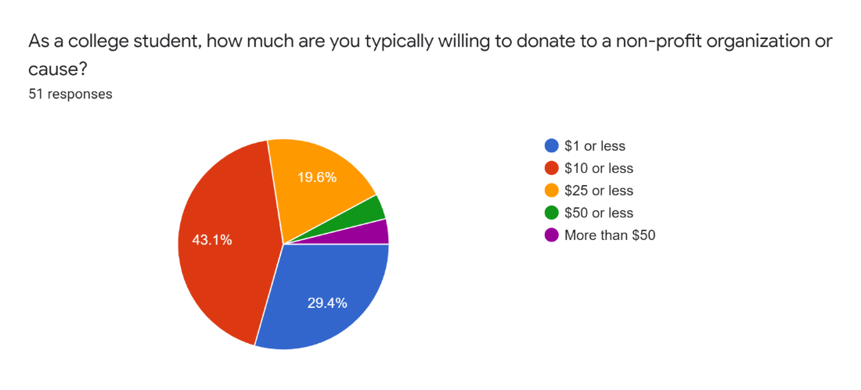

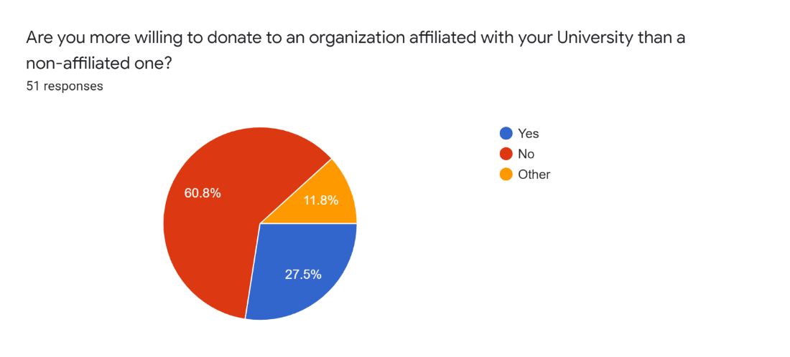

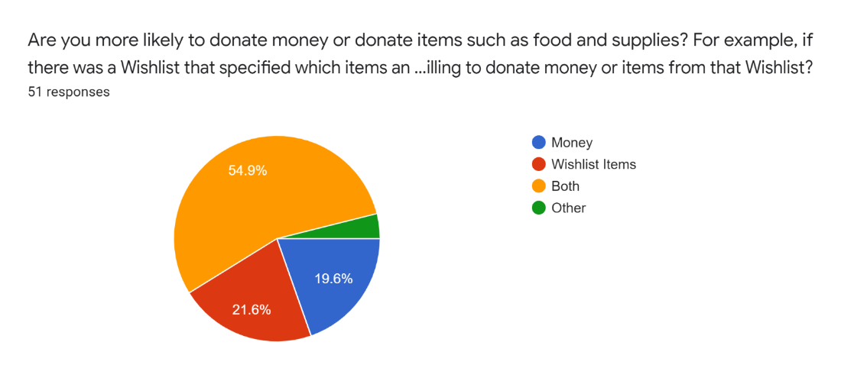

Process Models

**As-Is**

The current model of the website is expressed by the As-Is model. The current model of Cardinal Cupboard is quite simple. Just two options are presented to the user when they first visit the site: Volunteer or Donate. Clicking donate presents three options: monetary, amazon wish list, or email. Clicking volunteer only currently allows users to volunteer via email. All these options lead to the main goal of helping students with food insecurity.

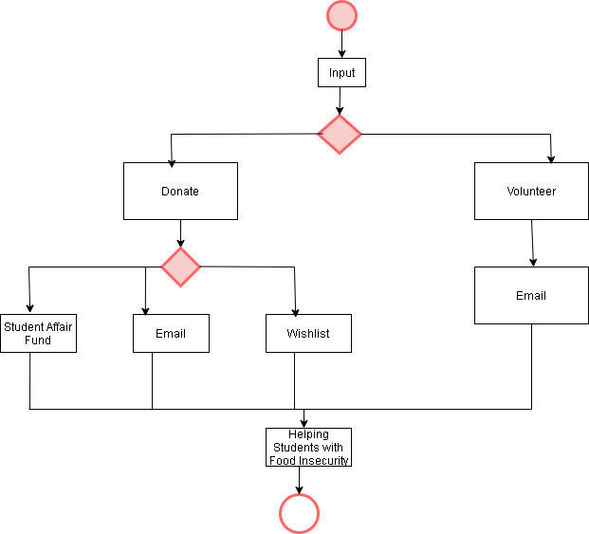

**To-Be**

The To-Be Model describes how we envision the new website to operate. It is much more complex compared to the As-Is Model. Once again as users first load the website, they are presented with two choices: staff login, and guest user.

For staff login, users will have three choices after logging in. These choices are: inventory management, links to Engage finances, and scheduling.

For guest users three main options are presented. These options include: about us, getting involved, and resources.

For about us three options are available: mission, history, and team. For Resources, four options are available: grab and go, recipes, HelperHelper, and additional help.

For getting involved, we wanted a much more fleshed out system. Users have two main options: donate or volunteer. For donating the options are either a monetary donation, or through amazon wish list. For volunteering, three options are available: volunteer highlights, individual opportunities, and organization opportunities.

All of these lead to the same theme as the As-Is model: helping students with food insecurity.

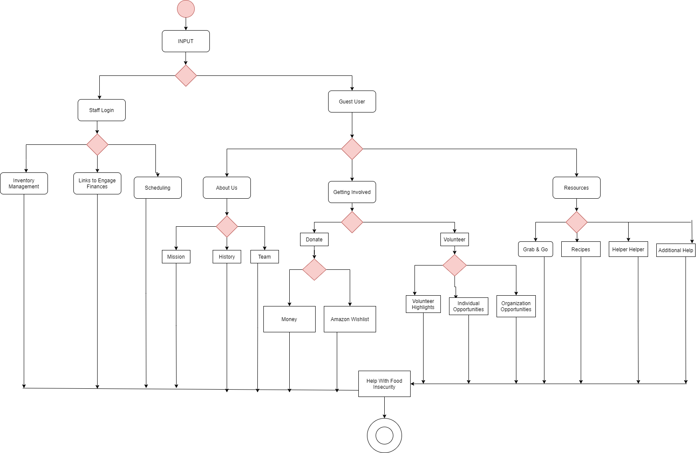

Agile Stories

|  |  |  |  |  |
| --- | --- | --- | --- | --- |
| **ID** | | 01 | | |
| **Title** | | Our Story | | |
| **As a** | | Customer | | |
| **I want to** | | Know more about the background of Cardinal Cupboard | | |
| **So that** | | I can trust this company and know where my money is going towards | | |
| **When I** | Go to learn more about the Cardinal Cupboard | | **This happens** | There is a section describing who they are/who they serve, a mission statement, history, and sponsors |
|  |  |  |  |  |

|  |  |  |  |  |
| --- | --- | --- | --- | --- |
| **ID** | | 02 | | |
| **Title** | | Need for Inventory | | |
| **As an** | | Staff Member | | |
| **I want to** | | Have an inventory of our products | | |
| **So that** | | I know when to restock our inventory | | |
| **When I** | Am running out of something | | **This happens** | I can see when the inventory is getting low.  I can contact Dare to Care for more product. |
|  |  |  |  |  |

|  |  |  |  |  |
| --- | --- | --- | --- | --- |
| **ID** | | *03* | | |
| **Title** | | *Van Usage* | | |
| **As** | | *Volunteer* | | |
| **I want to** | | *Monitor the company van* | | |
| **So that** | | *Management knows when the van is due for maintenance* | | |
| **When I** | *Write down in a log when I use the van* | | **This happens** | *There is a record of who uses the van to keep up with Insurance companies in case of a accident and for maintenance* |
|  |  |  |  |  |

|  |  |  |  |  |
| --- | --- | --- | --- | --- |
| **ID** | | *04* | | |
| **Title** | | *Finances* | | |
| **As** | | *Staff Member* | | |
| **I want to** | | *Keep track of finances* | | |
| **So that** | | *Know how much money is going In and coming out.* | | |
| **When I** | *Use a spreadsheet when any transaction with money happens* | | **This happens** | *There is a record to keep up with where money is going/ coming from* |
|  |  |  |  |  |

**Improving Cardinal Cupboard**

**Vision (Small Project)**

**Version 1.0**

**Revision History**

|  |  |  |  |
| --- | --- | --- | --- |
| **Date** | **Version** | **Description** | **Author** |
| 14/Sep/21 | 1.0 | First Version | Cyber 5 |
|  |  |  |  |
|  |  |  |  |
|  |  |  |  |

**Table of Contents**

1. Introduction 15

1.1 References 15

2. Positioning 15

2.1 Problem Statement 15

2.2 Product Position Statement 15

3. Stakeholder and User Descriptions 15

3.1 Stakeholder Summary 15

3.2 User Summary 16

3.3 User Environment 16

3.4 Summary of Key Stakeholder or User Needs 17

3.5 Alternatives and Competition 18

4. Product Overview 18

4.1 Product Perspective 18

4.2 Assumptions and Dependencies 18

5. Product Features 19

6. Other Product Requirements 20

**Vision (Small Project)**

1. **Introduction**

The purpose of this document is to collect, analyze, and define high-level needs and features of Cardinal Cupboard. Cardinal Cupboard is a local nonprofit organization that is need of an upgrade to their website. Cardinal Cupboard would like to improve their website in many ways including: adding more business processes, making the website easier to locate, marketing the website better, and other ways to help increase donations (whether it be time, funds, or supplies).

1. **References**
2. **Positioning**
3. **Problem Statement**

|  |  |
| --- | --- |
| The problem of | Website Layout |
| affects | Customers, Employees, Volunteers |
| the impact of which is | Less interaction with Cardinal Cupboard |
| a successful solution would be | More donations, customers, integration of software |

1. **Product Position Statement**

|  |  |
| --- | --- |
| For | *Cardinal Cupboard* |
| Who | *Needs more outreach* |
| The (product name) | *Website* |
| That | *Expands Cardinal Cupboard* |
| Unlike | *Feeding Kentucky* |
| Our product | *Allows to request food online* |

1. **Stakeholder and User Descriptions**
2. **Stakeholder Summary**

|  |  |  |
| --- | --- | --- |
| **Name** | **Description** | **Responsibilities** |
| Dare to Care Food Bank | Food Bank | *Donated a cooler and refrigerator*  Gives food items every week that are picked up |
| Lord’s Kitchen | Food Distribution | *Cardinal Cupboard donates any food they are unable to distribute* |
| Aramark | Dining Provider on UofL campus | *Collects food left over at the end of the day from multiple campus restaurants* |
| Kroger | Supermarket | *Donates storefront-level shelfing, a van, freezers, and coolers*  Renovate and repurpose a conference room in the SAC  Gives items that can no longer be sold in stores |
| Commonwealth Credit Union | Credit Union | *Gave $1,000,000 over 10 years* |

1. **User Summary**

|  |  |  |  |
| --- | --- | --- | --- |
| **Name** | **Description** | **Responsibilities** | **Stakeholder** |
| *Customers* | *Order food from Cardinal Cupboard* | *Entering information regarding what they want* | *Dare to Care Foodbank* |
| *Volunteers* | *Give their time to help run Cardinal Cupboard* | *Staff the Cupboard, temperature checks, logs food, monitor inventory* | *Dare to Care Foodbank* |
| *Donators* | *Donate food, items, or money to Cardinal Cupboard* | *Donating items and or money using the donation link.* | *Commonwealth Credit Union* |

1. **User Environment**

The number of people involved in completing a task is usually one. Most of the tasks involve staffing the store. The data collection and display are entirely automated by software. The number of people involved does not change. A task cycle is the amount of time the volunteer has signed up for. This is a number that can change. There are no environmental constraints. The system platform currently in use today is one iPad. We expect this to not change. Other applications already in use include GroupMe. Our applications will not need to integrate with it.

1. **Summary of Key Stakeholder or User Needs**

|  |  |  |  |  |  |
| --- | --- | --- | --- | --- | --- |
| **Need** | **Priority** | **Concerns** | **Current Solution** | **Proposed Solutions** | |
| Display Information Dynamically              Emphasize Donation options            Forms            Improve technology                Website design | High                High            High            High                High | We need a way to display information in a dynamic and constantly updating manner.    We need to emphasize ways to donate on the page so it is recognized by more people    We need to create forms to know how many volunteers we currently have.    We need to improve technology to reach out to more people and inform them about Cardinal Cupboard      Website design is important to improve and the top priority, any good organization must have a great website. | None              A donation section of the website.            Currently this is done through HelperHelper.      One iPad                A basic and barebones website, with only two options. | | Display all information on the website of Cardinal Cupboard            Include a much more fleshed out donation system with both Amazon Wishlist, and monetary donation.      A form for both guests, and employee login.        More technological devices that keep up with everything going on in the cupboard            A truly dynamic website with many choices for the user to partake in. |

1. **Alternatives and Competition**

Portland’s Food Pantry: They are a non-profit organization that relies on volunteers and donations.

**Major strengths: Quality of food, nice staff**

**Major Weaknesses: They do not have a website**

New Roots Fresh Stop Markets: On their website, a strength is that they mention their process by saying “Each bag contains nine varieties of fresh, local, mostly organically-certified vegetables and some fruit: $6 if paying with SNAP; $12 for limited resources; $25 for higher income; and, $40 for Food Justice Shares (small processing fees are added to each level except for $6). Everyone gets the same bag regardless of what they pay. “

**Major Strengths: Website available, nice design, good system with steps**

**Major Weaknesses: N/A**

Clifton Universalist Unitarian Church- Little Food Pantry:

**Major Strength: N/A**

**Major Weaknesses: Website not loading, not much information available other than how to contact them.**

**4. Product Overview**

**4.1 Product Perspective**

The product is a component of a larger system. The Cardinal Cupboard website is a subset of the UofL Involvement website. These systems interact with each other in a large way. The relevant interfaces are links at the top of the Cardinal Cupboard website that are pathways into the larger involvement website. These links are Home, About Us, Student Organizations, Fraternity & Sorority Life, Leadership, Service, and Covid 19 Resources.

**4.2 Assumptions and Dependencies**

* The content management system must be able to run on all types of devices. Such as phones, laptops, and desktops.

* The website must be able to run on Windows, Mac, and Android operating systems.

* Users and volunteers need a basic understanding of how to access a website.

**5.  Product Features**

When you first log on to the website you may either login or continue as a guest. The guest section is split up into different sections, each section with different product features. If you login there are different features available to you. You log in by using your ULink account, as Cardinal Cupboard is just for students, staff, and alumni.

Guest:

* About Us
* Mission Statement
* History
* Food Pantry Video (The video on their current website)
* Contact Us*
* Resources
* Grab-n-Go
* Campus Resources
* Links to external resources
* Recipes
* List of stock
* Forms to submit recipes
* Contact Us*
* Get Involved
* Donate
* Amazon Wishlist
* Fund For Student Affairs
* Drop-box Information
* Volunteer (Includes link to login)
* Contact Us*

Login:

* UofL Students, Staff, and Alumni
* Donate (Link back to donate page)
* Volunteer
* Cardinal Cupboard Staff
* Current Schedule of Volunteers
* Receive forms when submitted
* Inventory
* First-time Volunteers
* Current Schedule of Volunteers
* Form to submit which includes contact information, when they are available, etc.
* Contact Us*

*\*Contact Us will be at the bottom of every section, and will include email, phone number, address, and social media*

**6. Other Product Requirements**

The requirements for this to run are an Internet connection, and a device capable of accessing and displaying web pages. Volunteers will need an extremely basic understanding of how to access websites, and login using their university information. Fault Tolerance is high. If the servers that the website is hosted on are online, then the website will work. There are no design constraints. External Constraints are how well the website is received by customers. There are no other dependencies.

Team Charter

**Team Goals:**

The entire team will function as a cohesive unit. There are five different people, but we are all united towards one goal. That goal is to deliver the best possible product to the client. One of the main team goals is to make efficient use of the meeting. This will allow the group to do iterations in a timely manner.

There will also be extremely detailed communication between team members. If group members are detailed in their communication, there is less room for mistakes. Communication between team members will be a daily occurrence. By communicating daily, team members will always be on task. Building relationships is also a team goal. We are in this together until the end.

Each group member is responsible for contributing to the iterations. An important team goal is the organized storage of files. Another goal is to make Microsoft Teams the preferred spot to meet, and to do work. Microsoft Teams is preferred because all group members have immediate access to any file. In addition, group members can work on projects at the same time. Finally, a good goal to live by is, “No one person should be doing more work than another.”

**Meeting Times:**

The team should strive for at least four meetings each week. Team meetings will be conducted weekly at two guaranteed times. These times are Mondays, and Wednesdays, from 9:30-10:45AM. Team members will meet in person when it is convenient to do so, with as many team members as possible. When in person meetings are impossible, Microsoft Teams will be used to conduct group meetings. Team meetings will be devoted to the discussion and completion of iterations. Assignments should be done on your own time, unless otherwise necessary. Study should also be done on your own time, unless otherwise necessary.

**Communication:**

The team will communicate with each other primarily through SMS messaging. Texting through SMS is preferred because everyone will usually have their phones on them. Microsoft Teams chats can also be used to communicate when needed. Communication between the team and instructor will be done via the use of email. When convenient, team members can also meet with the professor in person. This can be done with office hours, or in the classroom.

**Team Decisions:**

The team will build consensus by attempting to meet the interests and concerns of as many group members as possible. In addition, the team will only make decisions in ways that accommodate as many group members as possible. Everyone has a right to their opinion, and all opinions will be considered. No one team member should be deciding everything.

**Project Repository:**

The team will maintain documentation of the iterations with the aid of Microsoft Teams. The Microsoft teams should be organized extremely well. Folders will be created to assist in the organization of files. For instance, iteration one will have its own folder, and iteration two, and three, and so on.

Another benefit of Microsoft Teams is that files are automatically backed up, so loss of data is of little concern. However, to be sure, all files will be backed up to an external flash drive weekly. Matthew Roth oversees the backing up the files.